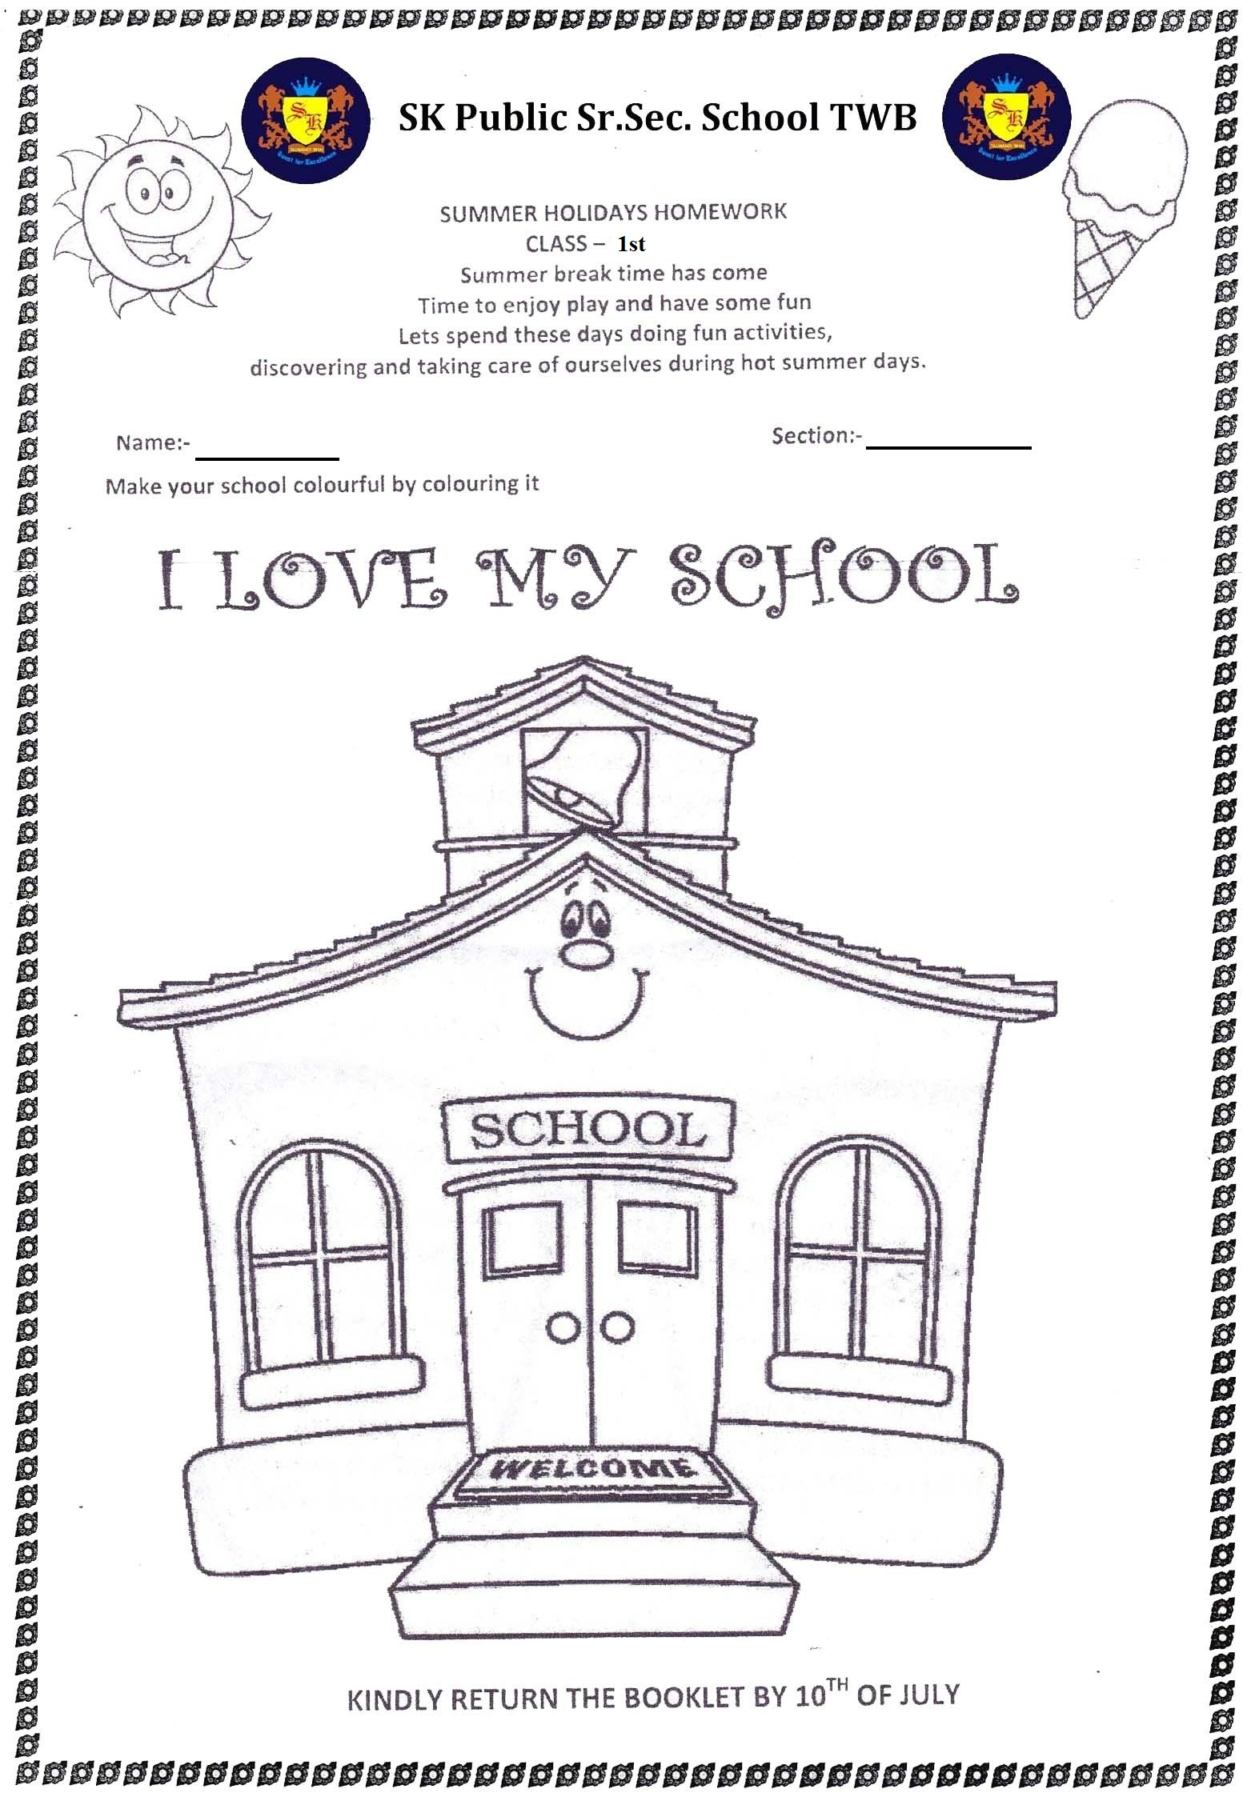

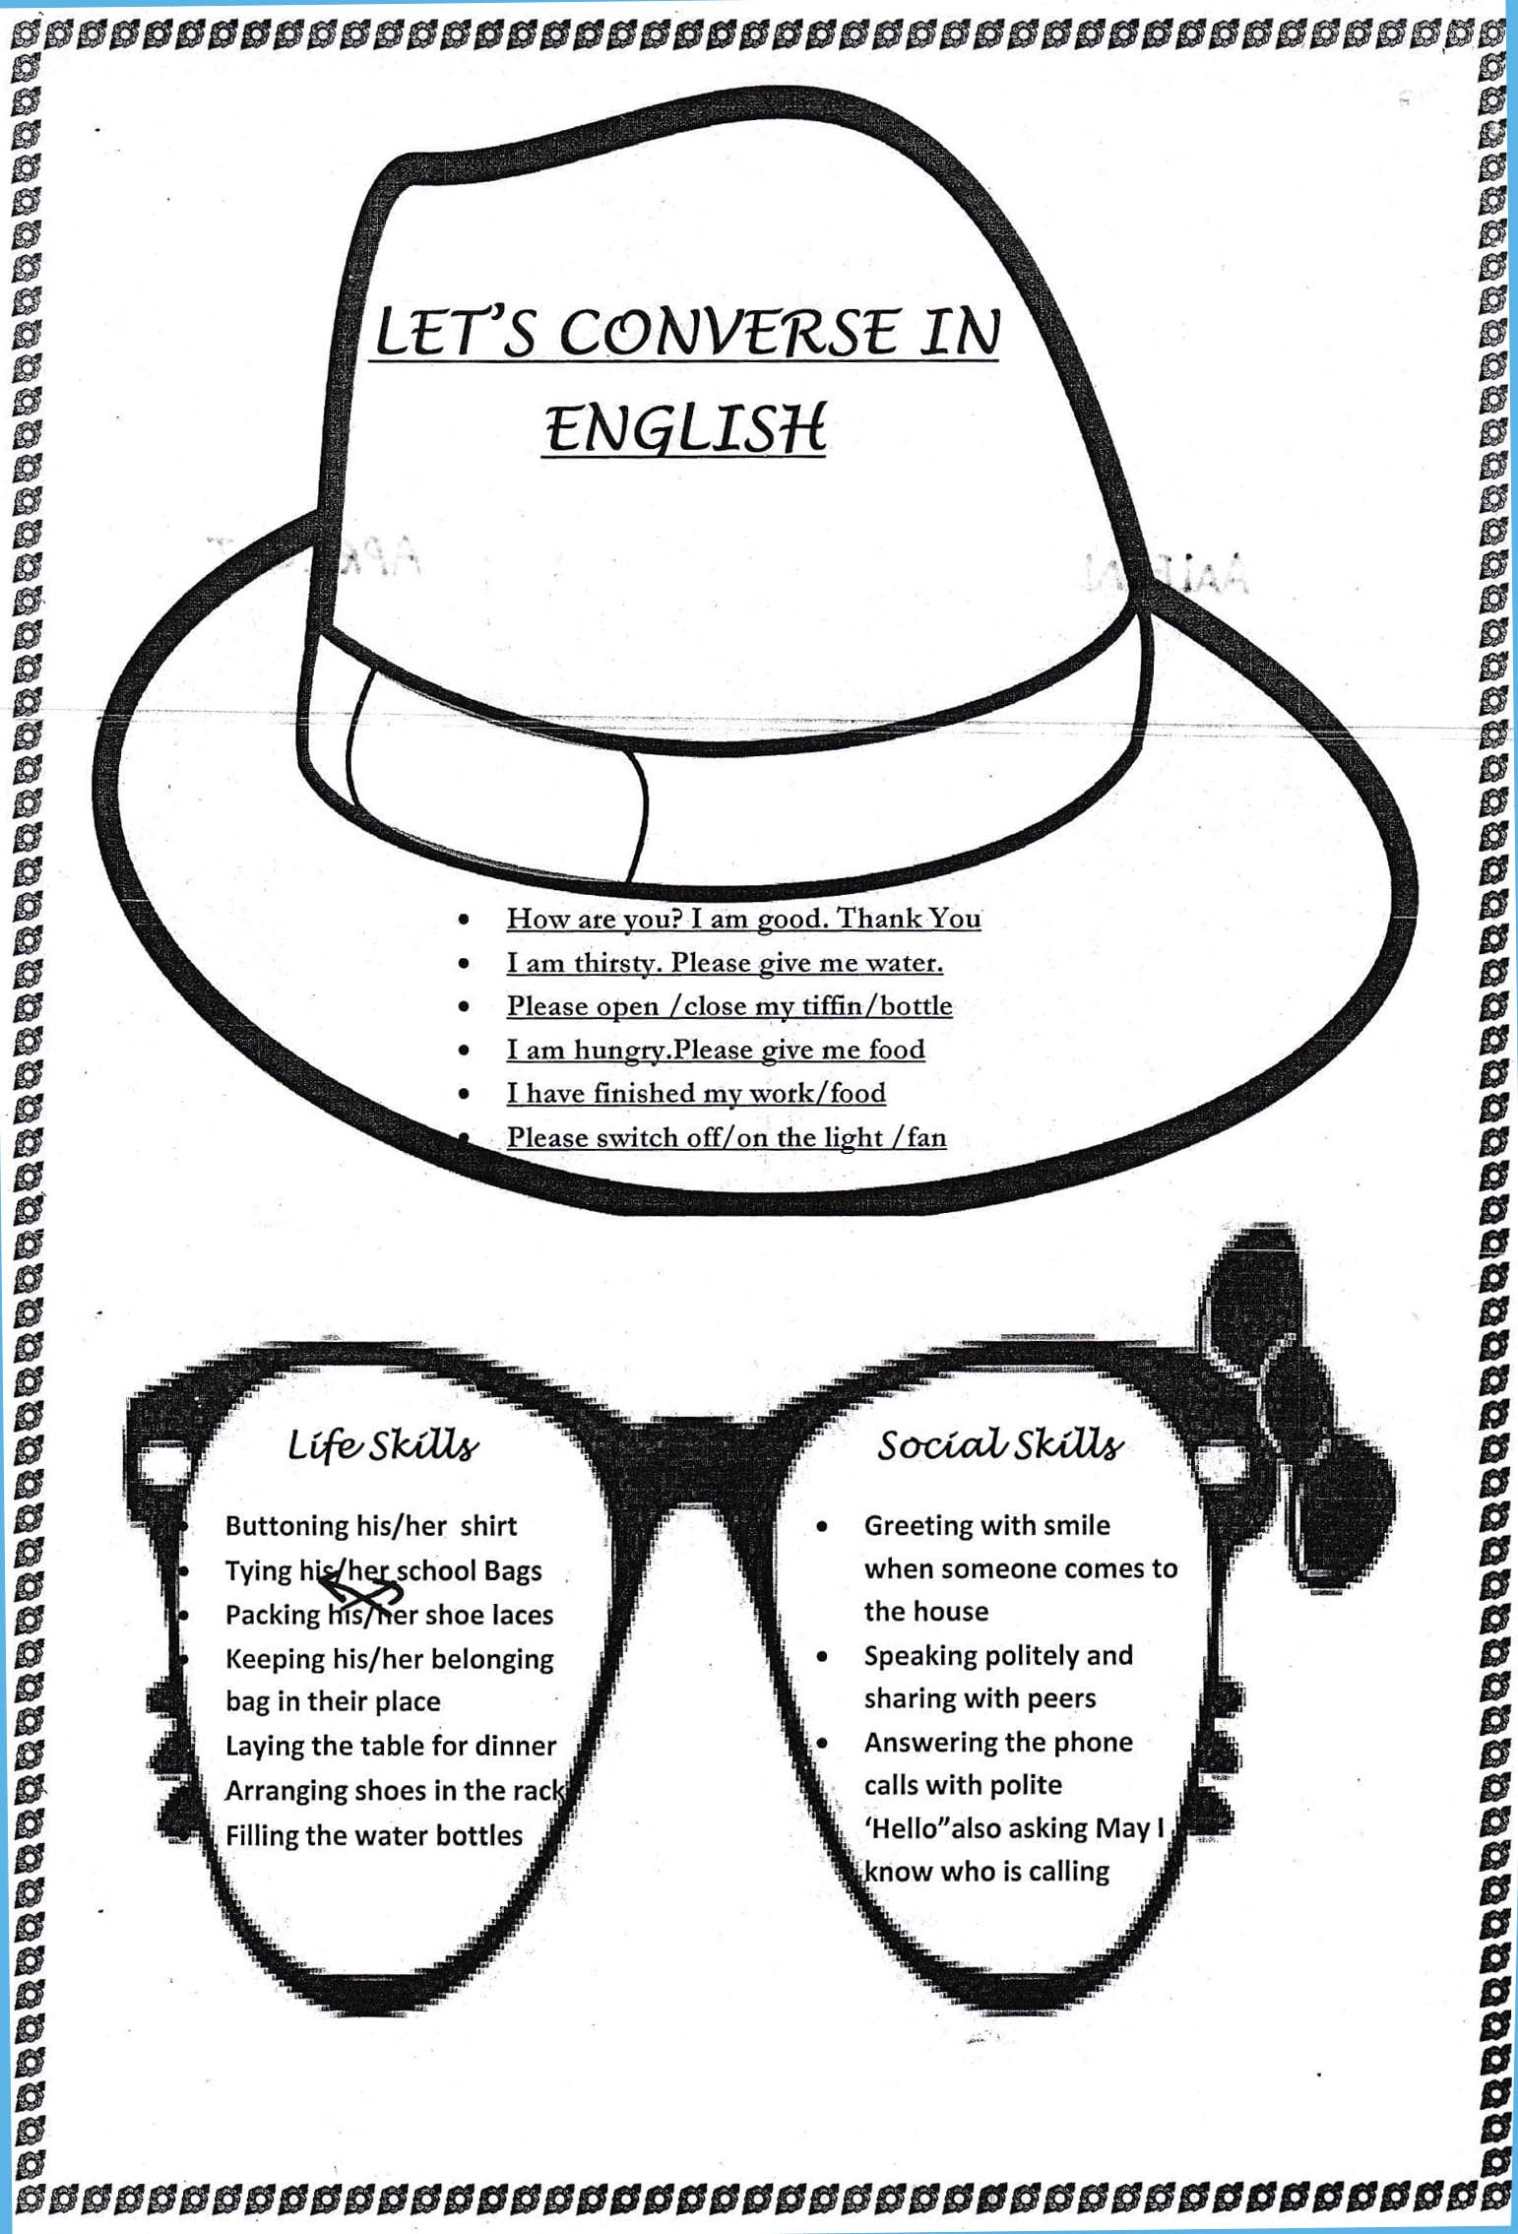

Dear Parents ,
warm greetings , Summer vacations will be starting 4th June 2018
- Spend quality time with your children, help them complete their holiday homework in neat hand writing.
- Inculcate good habits and good values in the child ,this will go a long way.
- Do not allow your children to use Mobile phones and watch T.V. rather let them play indoor and outdoor games.
- The School will reopen on 9th July at 7:45 AM.

English :-Ch-1,2,,3 learn from discovering and observation part -1 .
Page no. 32,33,40 ,41,42 do on observation book .writing-20 pages.
English Part 2 My observation Book - Page No:- 7,11,13,23,24,32,34,35,42,44,45,53,54,63,64,70,72
Math :-Ch -1, 2 full revise from discovering and observation book .Ch-3 ,4 complete on discovering and observation book. Tables 2 to 5 write and learn (2 times)
Math Part 2 My observation Book -Page No:-15,16,25,27,28,44,52,59,61,62,63,67,68,75
E.V.S :- Ch-1 ,2 full learn from discovering and observation book. Ch -3,4
complete on discovering and observation book .
E.V.S Part 2 My observation Book 1: -10,13,14,20,26,30,34,36,39,41,43,52,61
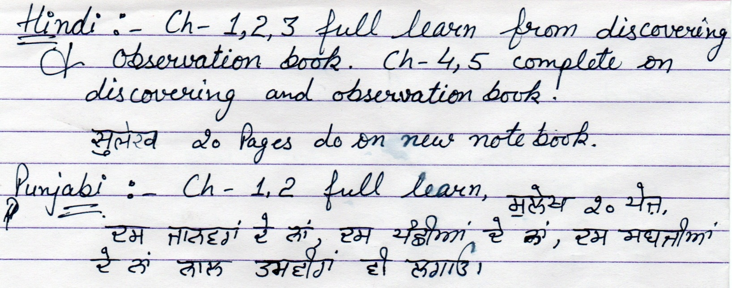
Hindi Part 2 My observation Book-Page No:-10,16,23,40,47,55,57,64,71 on Book

