S.K Public School Talwandi Bhai
Holidays Home Work Class -2nd

Dear Parents ,
warm greetings , Summer vacations will be starting 4th June 2018
- Spend quality time with your children,help them complete their holiday homework in need hand writing.
- Inculcate good habits and good values in the child ,this will go a long way.
- Do not allow your children to use Mobile phones and watch T.V. rather let them play indoor and outdoor games.
- The School will reopen on 9th July at 7:45 AM.

Maths : Write 2 to 10 Table , Ch-4 (more about numbers /and Ch- 5 (Addition with carry) Complete on both
book (My observation + discovering book).
Do application section-57,58,71,72 My observation (Part 1)
Do C³ (objective section)-73 or 74 , 59 or 60 My observation (Part 1)
English : 1). Do one page daily for improvement of handwritten (Cursive)
Ch-3 (Neera and Tara),Ch 4 (Aryan $ the pizza) complete the pages 56,57,58 (fillups with help of
Adjective on Discovering book.
Do application section-43,44,55,56 My observation (Part 1)
Do C³ (objective section)-45 or 46 , 56 or 57 My observation (Part 1)
Write short note on friendship.

E.V.S- Revise Ch1 to 3 from both books.
Prepare a small chart on the topic given in the class wild and domestic animals or sense organs.
Discovering book Do page 38(Color the Picture) page 43 (describe the picture and arrange the unjumbled words)
Page 48 write the name of young ones of animals.Do $ document section page 34,49.
Do application section- page 31,32,41,42 My observation (Part 1)
Do C³ (objective section)- page 33 or 34 , 43 or 44 My observation (Part 1)
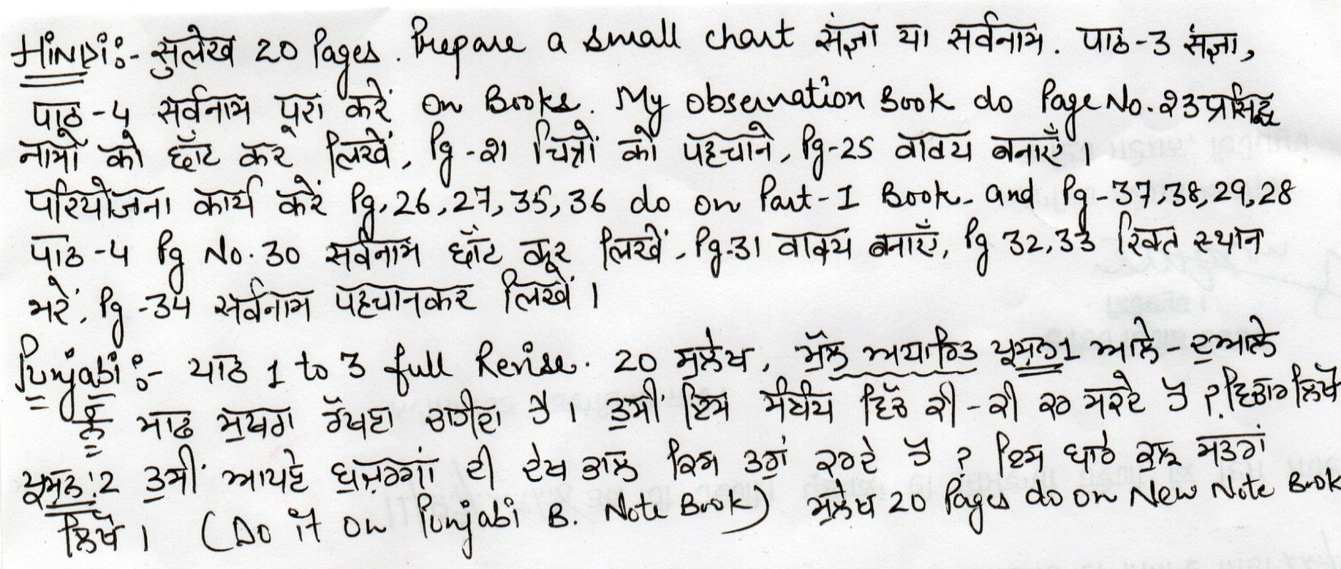
Read Ch 3 & 4 also underline important points

