S.K Public School Talwandi Bhai
Holidays Home Work Class -3rd

Dear Parents ,
warm greetings , Summer vacations will be starting 4th June 2018
- Spend quality time with your children,help them complete their holiday homework in need hand writing.
- Inculcate good habits and good values in the child ,this will go a long way.
- Do not allow your children to use Mobile phones and watch T.V. rather let them play indoor and outdoor games.
- The School will reopen on 9th July at 7:45 AM.

English : 1). Ch 1 to 3 learn from discovering Eng. & My observation Part -1 Book -20 Pages
Hand Writing.
Activity Based :- 1.Write your thoughts of the story “ As you saw so shall you reap”.
2). Write a letter to your friend to describe your summer vacations and the activities
you did.
3). My observation Part-1 Page-36-37 do on Book ( Homophone )
Maths : Table 1 to 10 Write “ a learn, write do and Document activity of Ch-1,2,3 from
discovery Maths on rough NB.,
Revise Ch 1,2,3 full from discovery observation Math’s , Make a Chart on even and
odd numbers (100 to 200)
S.St : Ch1,2,3 Learn from Discovering and observation book.For activity Do page no:-33 to
36 ,43 to 46 and 54 to 56 on
Observation Book. Make a chart on Earth revolution and phases of Moon.
Science: - Make the diagram of types of teeth (page-24) and structure of tooth (Page-26)
-Cut the picture of your favorite food items and healthy food items and paste on chart
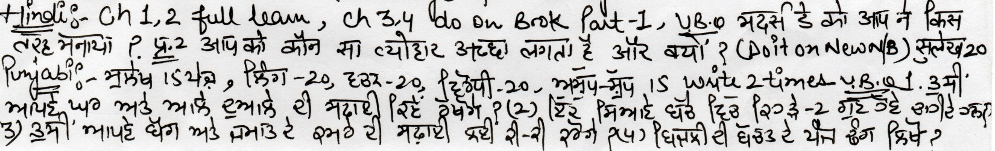
and make collage for Activity.

