S.K Public School Talwandi Bhai
Holidays Home Work Class -5th

Dear Parents ,
warm greetings , Summer vacations will be starting 4th June 2018
- Spend quality time with your children,help them complete their holiday homework in neat hand writing.
- Inculcate good habits and good values in the child ,this will go a long way.
- Do not allow your children to use Mobile phones and watch T.V. rather let them play indoor and outdoor games.
- The School will reopen on 9th July at 7:45 AM.
Maths : 1. Write and learn table from 1 to 20.
2. Make a chart on roman numbers [50 to 100].write in roman.
3.write do and document activity of Ch-1 and Ch-2, Ch-3 on rough
notebook.
4.Revise Ch-1,2,3 of discovery and observations math’s on revision
notebook.
English : 1.read L-3 and L-4 and find out 15-15 extra W/M from the dictionary and write in H/W notebook.
2.write 20 pages in neat and clean writing.
3.write paragraphs on the given topics (i) value of books (ii) value of games (iii) save environment
(iv) health is wealth (v)obey yours elders.
4.Do application and Do and document activity given in the books of
L-3 and 4.
5.Learn Ch-1,2 full + grammar part.
S.St : 1.CH-1 and Ch-2 full learn.
2.read ch-3 and write new words, practice zones,mcq.Q/A on separate
notebook.
3.activity on workbook ,page no-31,32 and page no.-33,34.
4.make a project file on Nobel prize winners from page no-47 and 48.

Punjabi & Hindi-
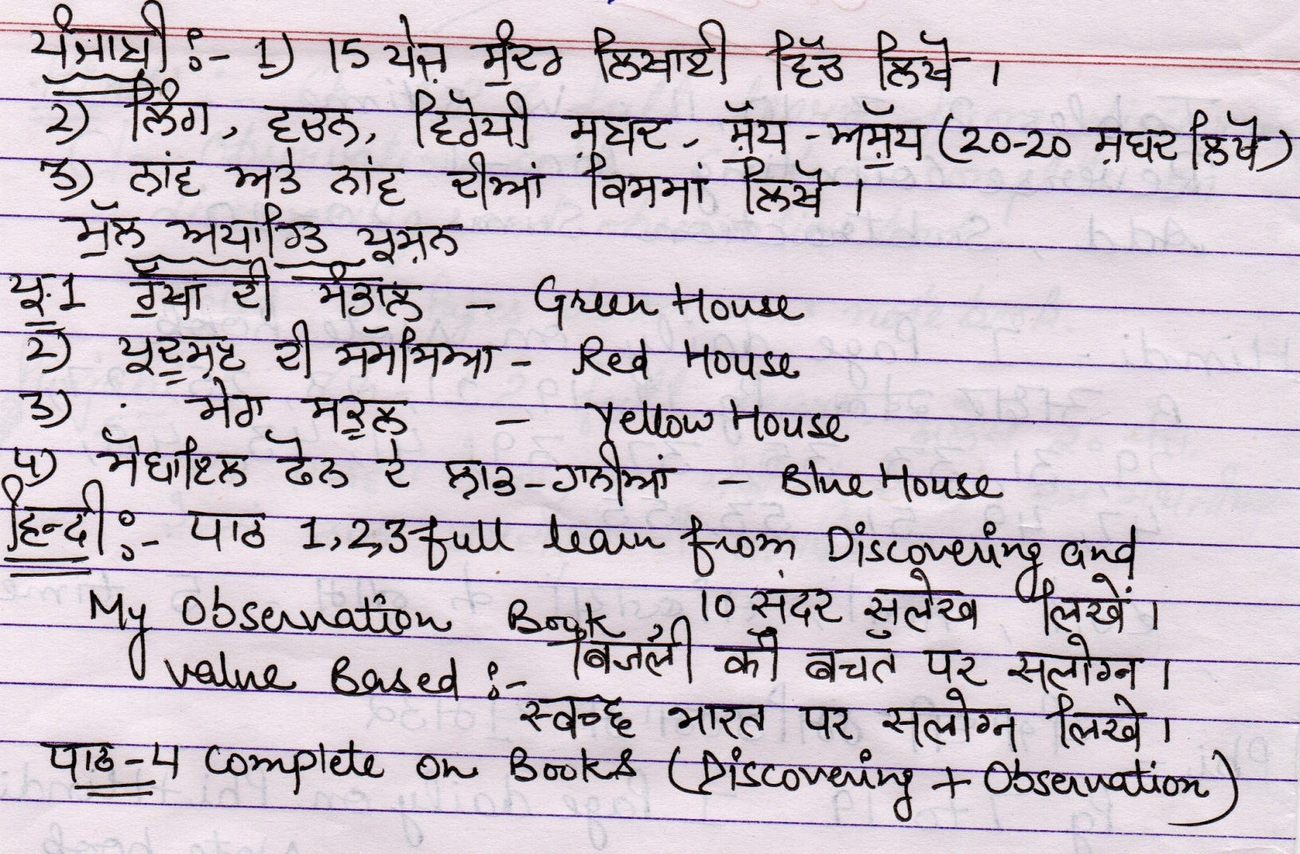

Science: - 1. Read ch-3 and ch-4.
2. activity (making diagrams) make chart (i) heart (ii) brain
(iii) spinal cord (iv) blood vessel)
3.make a slogan on (i) circulating system (ii) nervous system
4.Activity ----feel different types of actions at home.
(i)voluntary action (ii) Involuntary action (iii) automatic action
(iv) Reflex Action.
5.Make 2 model from two chapters.
Model-1---Light travels in straight light (9,12,15,22) ,
Model 2- central Nervous system (19,1,11)

Computer :- 1.Revise ch-1,2
GK- Learn page no -7 to 15

