S.K Public School Talwandi Bhai
Holidays Home Work Class -6th

Dear Parents ,
warm greetings , Summer vacations will be starting 4th June 2018
- Spend quality time with your children, help them complete their holiday homework in neat hand writing.
- Inculcate good habits and good values in the child ,this will go a long way.
- Do not allow your children to use Mobile phones and watch T.V. rather
let them play indoor and outdoor games.
- The School will reopen on 9th July at 7:45 AM.

Social Science:- History- ch 1,2 learn , Civics- Ch 1 learn, Geo- Ch 1 learn.
Ch 3rd of History and Ch 2nd of civics (Read,find,B.W as Qus/Ans Book write on notebook.
Activity: 1.make a presentation on the invention of wheat.
2.make a poster on the topic ‘equality and justice’.
Model making:-student will prepare a model on give topic by teacher with groups
Models Rural livelihood, urban livelihood, domains of earth,layes of the earth, evolution of human beings,
Oceanic and continental crust, solar system, global.
English:-Ch 4,6 Read + find meaning of at least 30 difficult words.
Grammar: 1 make a small chart of (Noun,pronouns,tenses,gender,adverb:write examples also).
3.comprehnsions( do in book )
4.writing pages -20 ----Comprehensions
5.antonyms,homophones ( write ) 20-20.
6story writing (tit for tat, the clever rabbit , honesty is best policy)
7.notice-yesterday, you were playing in the play ground in the school. You found a wrist watch there write a notice about it.
Science:- ch 3,4 read and Ch 1,2 revision
Activities:-Field visit-observe the movements of the following animals-any five (dog, monkey, etc..) write about any one feature of their moving patterns.
(ii). Make list on drawing paper of the following.
Q2. Label pics of all edible part of plant like (ii) pictures things are stem,flowers,root,leaves,fruit etc….)
4.case study any plant parts of a flower.
5.prepare saturated solution of water (activity)
6.Model making

1.pin hole camera 2.conductor and insulator 3. Show the presence of oxygen as nitrogen in air.
4.unlike poles attract each other and like pole repel each mother. 5.living & non living classification.
Computer:-chapter 1,2 learn.

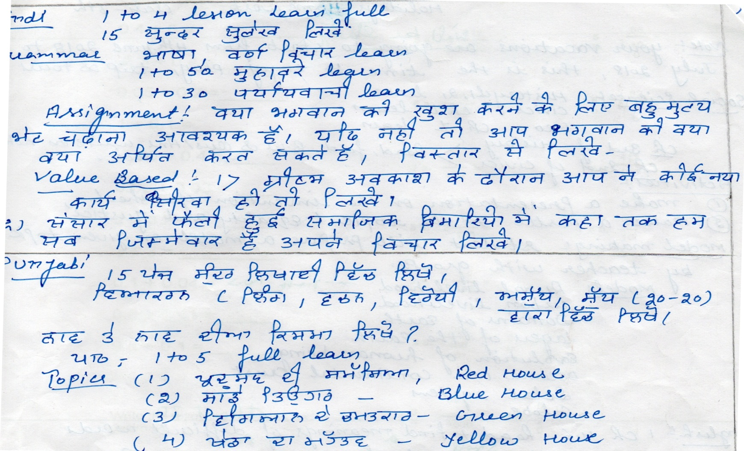
Hindi & Punjabi
Math :- NOTE :- Try to Attempt all the Sums as given below :-
A. Choose the correct option in questions 1 to 5:
1. Which is greatest?
a. 234 b. 543 c. 657 d. 456
2. Which is smallest?
a. 4567 b. 3456 c. 2345 d. 1234
3. What is 100 – 1?
a. 9 b.99 c. 999 d. 9999
4. What is the place value of 5 in ‘4567’?
a. 50 b. 5 c. 500 d. 5000
5. What is the sum of 567 and 843?
a. 567 b. 843 c. 1410 d. 1500
B. Fill in the blanks:
6. Number name of 45678 in Indian system of numeration is __________.
7. Place value of 4 in ‘56743’ is __________.
8. Expanded form of 6549 is ___________.
9. Number name of 756432 in international system of numeration is _________.
10. A box contains 5,00,000 medicine tablets each weighing 50 mg. What is the total weight of
all the tablets in the box in grams and in kilograms?
11. Population of Shivaji park was 2,35,471 in the year 2002. In the year 2012 it was found to
be increased by 72,958. What was the population of the city in 2012?
12. The town newspaper is published every day. One copy has 12 pages. Everyday
12,000 copies are printed. How many total pages are printed every day?
13. Which is greatest? 6895, 23787, 24569, 24567
a. 6895 b. 23787 c. 24569 d. 24567
14. Which is smallest? 25286, 25245, 25270, 25210
a. 25286 b. 25245 c. 25270 d. 25210
15. What is 1000 – 1?
a. 9 b. 99 c. 999 d. 9999
16. What is the sum of place values of 5 in ‘45675’?
a. 50 b. 5 c. 5005 d. 5000
17. What is the difference of 78456 and 34286?
a. 44170 b. 44000 c. 34286 d. 45670
18. Number name of 678905 in Indian system of numeration is __________.
19. Place value of 8 in ‘784567’ is __________.
20. Expanded form of 456789 is ___________.
21. Number name of 3456789 in international system of numeration is _________.
22. Starting from the greatest 5-digit number, write the previous five numbers in descending order.
23. Write 527864 using commas in Indian as well as International System of Numeration.
24.In Mumbai, the number of bicycles sold in the year 2011-2012 was 7,43,000. In the year 2012-2013, the number of bicycles sold was 8,00,100. In which year, more bicycles were sold and by how many?

Find the sum.
1 + 0.02 = _______ 0.2 + 0.1 =_______ 0.4 + 0.2 = ________
1 + 6 =__________ 0.06 + 4 = ______ 6 + 0.5 =________
0.00 + 3 = _______ 0.4 + 5 =________ 0.3 + 0.4 = ______
0.05 + 0.2 =______ 1 + 0.1 = _______ 0.05 + 0.4 =_____
0.06 + 0.03 = ____ 2 + 0.2 =________ 5 + 3 = _________
0.1 + 0.04 =______ 0.5 + 0.01 = _____ 0.3 + 0.1 =______
4 + 0.1 =_______
Write the following fractions as decimals.
1 a. 4 2 = 10 | 1 b. 5 208 = 1000
2 a. 6 94 = 100 | 2 b. 8 7 = 10
3 a. 766 = 1000 | 3 b. 4 1 = 10
4 a. 8 267 = 1000 | 4 b. 9 1 = 10
5 a. 4 812 = 1000 | 5 b. 1 66 = 100
6 a. 46 = 1000 | 6 b. 9 82 = 100
7 a. 58 = 100 | 7 b. 412 = 1000
8 a. 2 10 = 100 | 8 b. 5 = 10
9 a. | 3 34 =  100

2 a. 746 = 1000 | 2 b. 2 14 = 24
3 a. 9 65549 = 100000 | 3 b. 5 = 20
4 a. 2 = 3 | 4 b. 44 = 50
5 a. 4 8 = 10 | 5 b. 7 1 = 10

